CORE CIRCUITS AND COMPONENTS
Book 2 of the Electrical Engineering Series

Copyright © 2026 Lothar J. Musiol
All rights reserved.

Preface — How to Use This Book
This book assumes Book 1, Foundations of Electronics, as its starting point — specifically its Part III, which already covers Kirchhoff's laws, nodal and mesh analysis, Thévenin and Norton equivalents, superposition, and first-order transients in full. Rather than repeat that material, this book moves directly into what those techniques were building toward: real components with real limitations, and the analog and digital building blocks — op-amps, filters, and logic — that Book 1's idealized circuit elements were always in service of.
Each chapter follows the same shape as Book 1: it opens with the question the chapter answers, builds the picture in words first, works through it with fully solved examples, and closes with practice problems whose solutions appear in Appendix B. A Key Idea box marks the one fact worth carrying forward from a section; a Common Misconception box heads off a specific, predictable error before it happens.

How This Book Is Organized
Chapters 1–2 build the vocabulary shared by every later chapter: bias points, headroom, and small-signal behavior for analog circuits, and logic levels and noise margins for digital ones. Chapters 3–4 develop digital design specifically, from Boolean algebra through sequential circuits with memory. Chapter 5 introduces the operational amplifier as an ideal building block, in the same spirit Book 1 used for the resistor, capacitor, and inductor. Chapter 6 generalizes Book 1's filter and resonance results into a full filter-design vocabulary, passive and active. Chapters 7–9 close the book by returning to the resistor, capacitor, and inductor themselves — this time as real, physical parts with tolerances, ratings, and parasitic effects no ideal model captures.
Key Idea
This book does not re-teach Book 1's Part III. Network analysis (Thévenin, Norton, nodal, mesh) and transient analysis are assumed throughout — if a technique from those chapters feels unfamiliar, that is the place to go back to, not this book.

About This Series
This book is the second of twenty-one, together covering the full breadth of electrical engineering from first principles through to its specialized and emerging edges. Each book assumes only the books before it in the list below — never the ones after.
Book | Covers
1. Foundations | Physics, mathematics, and circuit theory
2. Core Circuits and Components (this book) | Analog and digital fundamentals, op-amps, filters, and real resistors/capacitors/inductors
3. Semiconductor Physics and Devices | Diodes, BJTs, MOSFETs, advanced materials, fabrication and packaging
4. RF and High-Frequency Engineering | Transmission lines, S-parameters, RF components and measurements
5. Noise and System Performance | Thermal, shot, and flicker noise; noise figure; SNR and BER
6. Modulation and Communication Theory | AM/FM/PM, digital modulation, coding, Shannon capacity
7. PLL and Frequency Synthesis | Phase detectors, loop filters, VCOs, frequency synthesizers
8. Microwave Engineering (1–30 GHz) | Waveguides, resonators, microstrip and stripline design
9. mmWave Engineering (30–300 GHz) | Propagation, packaging, phased arrays, 5G/6G systems
10. Antennas and Radiation | Antenna theory, radiation patterns, antenna simulation tools
11. EMC, EMI, and Emissions | Conducted and radiated emissions, shielding, regulatory standards
12. Wireless Systems and Protocols | Wi-Fi, Bluetooth, cellular architecture, MIMO systems
13. Radar Systems | Pulsed, CW, and FMCW radar; SAR; automotive radar
14. DSP and Software-Defined Radio | Sampling, digital filters, the FFT, SDR platforms
15. Power and Energy | Power systems, transformers, three-phase systems, renewables
16. Control and Automation | Feedback systems, stability, PID control, robotics
17. Oscillators, Modulators, and Transceivers | Oscillator topologies, receiver architectures, power-amplifier techniques
18. Technologies, Layout, and Packaging | PCB design, high-speed layout, substrates, advanced packaging
19. Simulation Tools and Methods | SPICE, ADS, HFSS, CST, and circuit/EM co-simulation
20. Debug and Validation | Oscilloscope, spectrum analyzer, and VNA debugging; failure analysis
21. Emerging Technologies | 6G, terahertz electronics, quantum devices, photonics, AI-driven RF design
Key Idea
You do not need the other twenty books to use this one. This book is written to stand on Book 1's foundation alone — treat the table as a map of where you have been and where a later interest can take you, not a syllabus you must complete in order.

Table of Contents
Preface — How to Use This Book
How This Book Is Organized
About This Series
Chapter 1 — Analog Electronics
Chapter 2 — Digital Electronics
Chapter 3 — Logic and Boolean Algebra
Chapter 4 — Combinational and Sequential Circuits
Chapter 5 — Operational Amplifiers
Chapter 6 — Passive and Active Filters
Chapter 7 — Resistors
Chapter 8 — Capacitors
Chapter 9 — Inductors
Appendix A — Formula Reference
Appendix B — Practice Problem Solutions
Appendix C — Glossary
Appendix D — Chapter Summaries
Appendix E — Further Reading

Chapter 1 — Analog Electronics
Book 1 treated resistors, capacitors, and inductors as ideal mathematical objects and solved circuits built from them exactly, once and for all. Real electronic design adds two things that book did not need: signals that carry information rather than just power, and circuits deliberately biased into a particular operating condition so that a smaller signal riding on top of that bias behaves predictably. This chapter builds the vocabulary — bias point, small-signal behavior, gain, and distortion — that every later chapter in this book, and every book after it, assumes.

1.1 Bias Points and Operating Conditions
A real analog stage is almost never asked to handle a signal that swings all the way from its most negative to its most positive possible value. Instead, a designer first sets a DC operating point — also called a bias point or quiescent point (Q-point) — a fixed voltage or current the circuit sits at with no signal applied. The actual signal of interest is then a smaller variation superimposed on that fixed point. Choosing the bias point well is largely a matter of leaving enough room, in both directions, for the signal to move without running into a hard limit.
Every real amplifying stage has such limits: an output that cannot go below its negative supply rail or above its positive one, no matter what the input asks for. The distance from the bias point to the nearer of these two rails is called headroom, and it sets the largest signal the stage can pass through undistorted.
Worked Example 1.1
Problem: A DC bias sets an amplifier's output operating point at 8 V. The output stage can swing between 0 V and 10 V before it distorts. Find the largest symmetric AC signal amplitude the stage can pass without clipping, and state which half of the cycle clips first if the amplitude is pushed beyond that.
Solution: The distance from the bias point to the upper rail is 10 − 8 = 2 V. The distance to the lower rail is 8 − 0 = 8 V. The smaller of the two headrooms sets the limit, so the largest undistorted amplitude is 2 V. Push the amplitude past 2 V and the positive peaks — the ones approaching the nearby upper rail — clip first, since that is the direction with less room to spare.
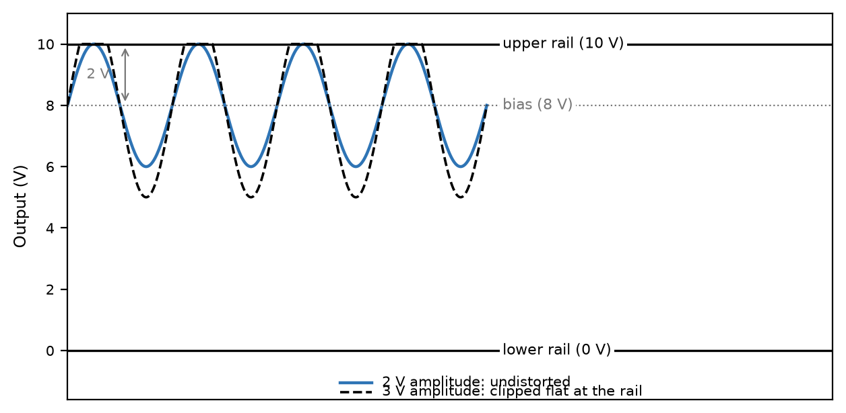
Figure 1.1 — A 2 V amplitude stays within the 8 V bias point's 2 V headroom to the upper rail; a 3 V amplitude clips flat against it.
Worked Example 1.2
Problem: A stage has a gain of 15 and is biased so its output sits at 3 V, with output rails at 0 V and 12 V. An input signal of amplitude 500 mV is applied. Will the output clip, and if so, on which side?
Solution: The demanded output amplitude is gain × input amplitude = 15 × 0.5 = 7.5 V. The headroom to the lower rail is 3 − 0 = 3 V; the headroom to the upper rail is 12 − 3 = 9 V. Since 7.5 V exceeds the 3 V lower headroom but not the 9 V upper headroom, the output clips only on the negative excursions, against the lower rail — an asymmetric clip, unlike the symmetric case in Worked Example 1.1.

1.2 Small-Signal Behavior
Once a bias point is fixed, the circuit's response to a small additional signal can often be treated as linear even when the underlying device is not linear over its full range — a fact this book will not derive in full until Book 3 introduces the transistor, but the concept is worth having in hand now. Near any single operating point, a smooth curve looks approximately straight; the smaller the signal, the better that approximation holds. This is why the phrase “small-signal” appears constantly in analog design: it is a promise that the signal is small enough for the surrounding nonlinearity to be ignored, not a claim that the underlying device is actually linear.
Key Idea
Headroom is the available signal range before a circuit hits a limiting mechanism such as clipping; push any real circuit far enough and it becomes nonlinear on its own, sometimes well before it reaches a rail — headroom and the small-signal linear approximation are related but not identical, and a circuit can leave the linear region without yet running out of headroom.

1.3 Gain and Distortion
Gain is the ratio of a stage's output signal to its input signal, and for a well-behaved linear stage it is a single number that does not depend on the size of the input. Distortion is what happens when that stops being true — typically because the signal has grown large enough to reach the edge of the stage's headroom (clipping) or because the underlying device's response was never quite linear to begin with, even for small signals. A clipped waveform is the most visible form of distortion: the peaks of the signal are simply cut flat at the rail voltage, and the output no longer resembles a scaled copy of the input.
Common Misconception
A higher-gain stage is not automatically a “better” one. Gain and headroom trade against each other for a fixed pair of supply rails: the more a stage amplifies a given input, the sooner an increase in that input drives the output into clipping. Selecting a gain is as much about how large the expected input signal is as it is about how much amplification the application needs.

Practice Problems
- A bias point is set at 6 V; the output swings between 1 V and 11 V. Find the largest symmetric AC amplitude the stage can pass without clipping, and identify which rail sets the limit.
- An amplifier stage has a gain of 20 and is biased so its output sits at 2 V, with output rails at 0 V and 5 V. Find the largest input signal amplitude that avoids clipping the output.
- Explain, in one or two sentences, why a small-signal analysis is only trustworthy near the specific bias point it was derived around.
- A stage has a gain of 8, output rails at 0 V and 9 V, and is biased at the center of that range. Find the maximum input amplitude before clipping.
- An amplifier's bias point sits at 1 V, with output rails at 0 V and 5 V. Which rail limits the headroom, and by how much?
- A designer doubles a stage's gain without changing its bias point or output rails. Explain what happens to the maximum undistorted input amplitude.

Chapter 2 — Digital Electronics
Every signal this book has discussed so far is continuous: it can take any value in a range, and that value itself carries the information. A digital signal takes a different approach entirely — it restricts itself to a small number of distinct states, almost always two, and accepts a cost in exchange for a considerable benefit. The cost is that a continuously varying real-world quantity must first be forced into one of those few states. The benefit is not that a digital signal is somehow immune to noise — no real signal is — but that its robustness comes from defining acceptable ranges for each state and regenerating a clean signal at every stage, rather than requiring every voltage to stay exact throughout. That is a strategy no analog signal, which must preserve its exact value all the way through, can fully share, and it is the reason nearly every modern system that can be built digitally, is.

2.1 Logic Levels and the Two-State Idea
A digital signal is defined by two ranges of voltage, not two exact voltages. Any value inside the “high” range is interpreted as a logic 1, and any value inside the “low” range is interpreted as a logic 0, regardless of exactly where within that range the voltage sits. A gap is deliberately left between the two ranges — a forbidden zone a valid signal is never supposed to occupy — and it is this gap that gives digital circuits their noise immunity.
Four voltages define the boundaries a manufacturer guarantees for a given logic family: the minimum output voltage guaranteed to be recognized as high (Vₒₕ, min), the minimum input voltage that will still be read as high (Vᵢₕ, min), the maximum output voltage guaranteed to be recognized as low (Vₒʟ, max), and the maximum input voltage still read as low (Vᵢʟ, max).

2.2 Noise Margin
The noise margin is the gap between what a gate is guaranteed to output and what the next gate down the line is guaranteed to still accept correctly, for each logic level separately:
NMʜ = Vₒₕ(min) − Vᵢₕ(min) NMʟ = Vᵢʟ(max) − Vₒʟ(max)
Any noise, ringing, or voltage drop smaller than the relevant noise margin can be added to a signal anywhere along its path without ever risking a misread bit. This is the source of digital electronics' most valuable property: a signal can pass through dozens of gates, each one imperfect and each one adding a little noise, and come out the other end exactly as clean as it went in — because each gate does not pass along the noisy analog voltage it received, it reads a bit and regenerates a fresh, full-strength output level.
Worked Example 2.1
Problem: A logic family specifies Vₒₕ(min) = 2.4 V, Vᵢₕ(min) = 2.0 V, Vₒʟ(max) = 0.4 V, and Vᵢʟ(max) = 0.8 V. Find both noise margins.
Solution: NMʜ = Vₒₕ(min) − Vᵢₕ(min) = 2.4 − 2.0 = 0.4 V. NMʟ = Vᵢʟ(max) − Vₒʟ(max) = 0.8 − 0.4 = 0.4 V. This circuit can tolerate up to 0.4 V of noise on either a high or a low signal without a single bit being misread — these are, in fact, the standard values for classic TTL logic.
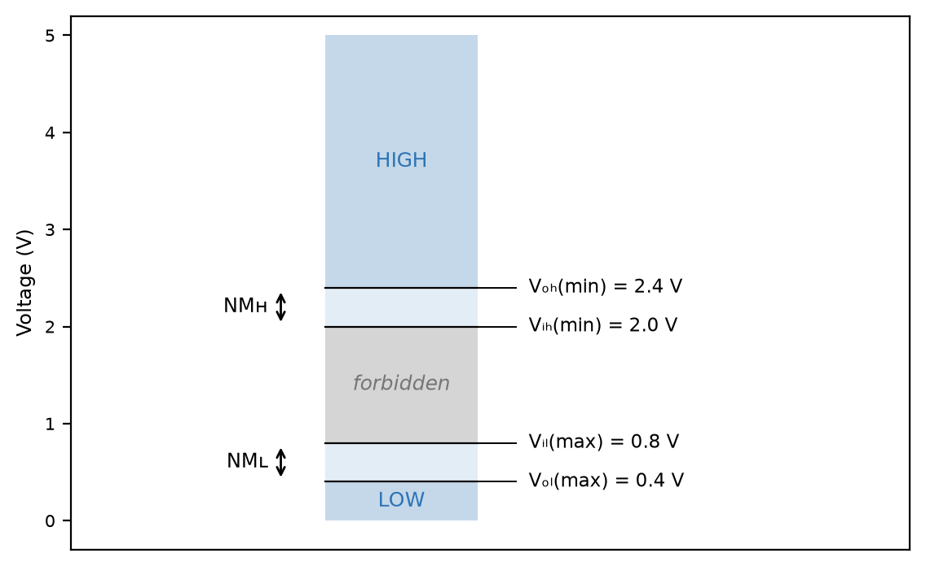
Figure 2.1 — The forbidden zone between Vᵢʟ(max) and Vᵢₕ(min), with the noise margins NMʜ and NMʟ on either side.
Worked Example 2.2
Problem: A 3.3 V logic output (Vₒₕ(min) = 2.8 V, Vₒʟ(max) = 0.2 V) drives the input of a 5 V logic gate (Vᵢₕ(min) = 2.0 V, Vᵢʟ(max) = 0.8 V). Find both noise margins for this mixed-voltage connection.
Solution: NMʜ = Vₒₕ(min) − Vᵢₕ(min) = 2.8 − 2.0 = 0.8 V. NMʟ = Vᵢʟ(max) − Vₒʟ(max) = 0.8 − 0.2 = 0.6 V. The two margins need not match, as they do for a single logic family — mixing families gives an asymmetric result, here more tolerant of high-side noise than low-side.

2.3 Gates as Amplifiers Driven Hard
A logic gate is, at the component level, built from the same amplifying devices Book 3 will introduce — it is not a fundamentally different kind of circuit from the analog stages in Chapter 1. What makes it digital is a design choice: rather than being biased for a well-behaved linear region the way an analog amplifier is, a gate is deliberately driven hard between its two extremes, spending as little time as possible in the in-between region where its behavior would be unpredictable and analog-like. Chapter 1's headroom concept still applies; a digital gate simply chooses to operate at the very edges of its available range instead of in the comfortable middle.
Key Idea
Digital robustness comes from regeneration, not from the absence of noise. Every gate reads a fuzzy analog input and outputs a fresh, full-strength digital level — noise that entered one stage is thrown away, not carried forward, which is precisely what an analog stage cannot do.

Practice Problems
- A logic family specifies Vₒₕ(min) = 3.5 V, Vᵢₕ(min) = 2.0 V, Vₒʟ(max) = 0.2 V, and Vᵢʟ(max) = 0.5 V. Find both noise margins.
- Convert the binary number 1011 to decimal.
- Explain, in a sentence or two, why a long chain of analog amplifier stages degrades a signal while a long chain of digital gates does not.
- A logic family specifies Vₒₕ(min) = 4.4 V, Vᵢₕ(min) = 3.15 V, Vₒʟ(max) = 0.1 V, and Vᵢʟ(max) = 1.35 V. Find both noise margins.
- Convert the binary number 11010 to decimal.
- Two logic families have identical noise margins on paper, but one is used in an electrically noisy industrial environment. Explain why matching noise margins alone doesn't guarantee reliable operation in practice.

Chapter 3 — Logic and Boolean Algebra
Digital circuits process bits, and bits are combined according to a small, complete algebra first formalized by George Boole a full century before the transistor existed. Boolean algebra gives a digital designer exactly what ordinary algebra gives a circuit analyst working with real numbers: a set of rules for simplifying an expression without having to re-derive its truth table from scratch every time.

3.1 The Three Basic Operations
Every Boolean expression, however complicated, is built from just three operations. AND (written as multiplication, AB) is true only when both A and B are true. OR (written as addition, A + B) is true when either A or B (or both) is true. NOT (written A′, or with an overbar) inverts a single variable. A truth table lists every combination of inputs and the resulting output, and it is the ultimate authority on what a Boolean expression means — two expressions are equal if and only if they produce the same truth table.

3.2 The Algebra of Simplification
Several laws let an expression be rewritten into an equivalent, simpler form without checking a truth table by hand. The commutative and associative laws work exactly as they do in ordinary algebra. The distributive law holds in both directions: A(B + C) = AB + AC, and, less familiarly to anyone coming from ordinary algebra, A + BC = (A + B)(A + C). The absorption law, A + AB = A, removes a term that adds no new information. De Morgan's laws convert one operation into the other: (A + B)′ = A′B′, and (AB)′ = A′ + B′.
Worked Example 3.1
Problem: Simplify F = AB + AB′ + A′B using Boolean algebra, and confirm the result against a truth table.
Solution: Factor the first two terms: AB + AB′ = A(B + B′) = A·1 = A. That leaves F = A + A′B. By the distributive identity A + A′B = A + B (multiply out (A + A′)(A + B) = 1·(A + B) = A + B, which is exactly A + A′B written the other way), F simplifies to A + B. Checking all four input combinations against the original expression confirms the two agree in every row: F = A + B.
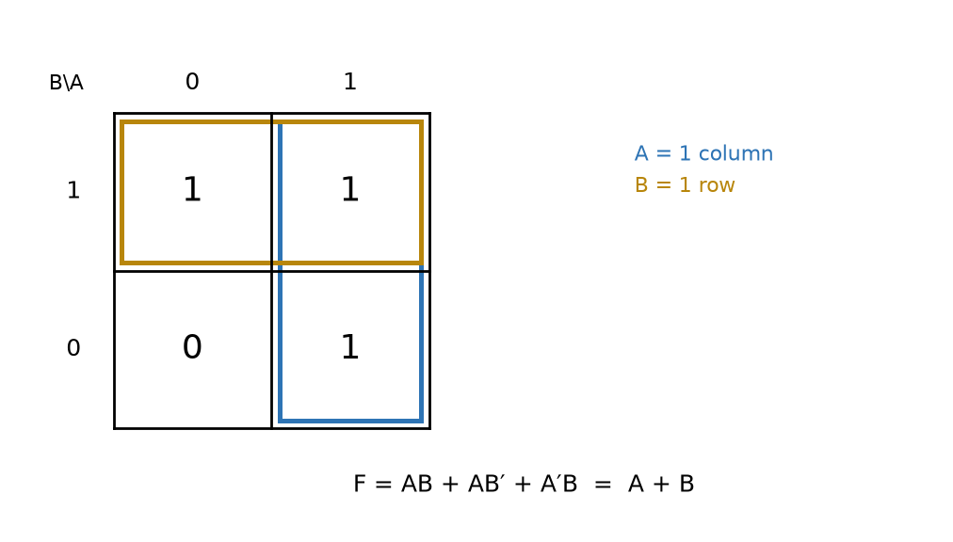
Figure 3.1 — A Karnaugh map for F = AB + AB′ + A′B: the A = 1 column and the B = 1 row each group to a single term, giving F = A + B.
Worked Example 3.2
Problem: Simplify G = AB + A′C + BC using Boolean algebra.
Solution: The term BC is a consensus term of AB and A′C — the consensus theorem states that whenever a variable (here, A) appears uncomplemented in one term and complemented in another, the third term formed from the remaining literals of both (here, BC) is redundant and can be dropped: G = AB + A′C + BC = AB + A′C. Checking all eight input combinations against the original three-term expression confirms the two agree in every row.
Key Idea
De Morgan's laws are the reason NAND and NOR gates are each, individually, universal: since AND, OR, and NOT can all be rebuilt from either one alone, an entire digital system can be constructed from a single type of gate — a principle some minimalist or historical designs take literally, even though modern chips mix many gate types chosen for power, area, and timing.

3.3 Karnaugh Maps
For expressions with more than two or three variables, spotting the right sequence of algebraic simplifications by inspection becomes difficult. A Karnaugh map arranges a truth table's outputs into a grid where every adjacent cell differs in exactly one input bit, so that groups of adjacent 1s can be circled and read off directly as a simplified term — a visual shortcut to the same simplifications the algebra provides, and the standard tool for anything up to about four or five variables.
Common Misconception
Two Boolean expressions that happen to agree for a few input combinations you happened to check are not necessarily equal. Only a full truth table match — every row, not a convenient sample — proves two expressions are the same function; a Karnaugh map or the algebraic laws above are what guarantee that, an ad-hoc spot check does not.

Practice Problems
- Simplify F = A(A + B) using Boolean algebra, and name the law used.
- Write out the truth table for F = A′B + AB′, and identify the operation this expression represents.
- Apply De Morgan's law to simplify (A + B)′.
- Simplify H = A + AB′C using Boolean algebra, and name the law used.
- Simplify F = A′B′C′ + A′B′C + A′BC′ + A′BC using Boolean algebra.
- Apply De Morgan's law twice to simplify ((A + B)·C)′.

Chapter 4 — Combinational and Sequential Circuits
Boolean algebra describes what a circuit computes; this chapter is about the two fundamentally different ways a real circuit can be built around it. A combinational circuit's output depends only on its present inputs — it has no memory of what came before. A sequential circuit's output depends on its present inputs and on its history, which requires the circuit to store state somewhere. Nearly everything a digital system does is some combination of the two.

4.1 Combinational Building Blocks
A half adder adds two single bits, A and B, producing a sum bit S = A ⊕ B (the XOR operation from Chapter 3's practice problems) and a carry bit C = AB. A half adder cannot accept a carry from a previous stage, which is what makes it “half” rather than complete. A full adder fixes this by accepting a third input, a carry-in Cᵢₙ, and can therefore be chained: the carry-out of one full adder becomes the carry-in of the next, building an adder for numbers of any width one bit at a time.
Worked Example 4.1
Problem: Build a full adder from two half adders and a single OR gate, and verify it correctly adds A = 1, B = 1, Cᵢₙ = 1.
Solution: The first half adder combines A and B: S₁ = A ⊕ B = 1 ⊕ 1 = 0, and C₁ = AB = 1. The second half adder combines that sum with the carry-in: S = S₁ ⊕ Cᵢₙ = 0 ⊕ 1 = 1, and C₂ = S₁·Cᵢₙ = 0·1 = 0. The final carry-out is C₁ + C₂ = 1 + 0 = 1 (an OR gate combining the two half-adder carries). The result, sum = 1 and carry = 1, is exactly 1 + 1 + 1 = 3, written in binary as 11 — confirming the circuit.
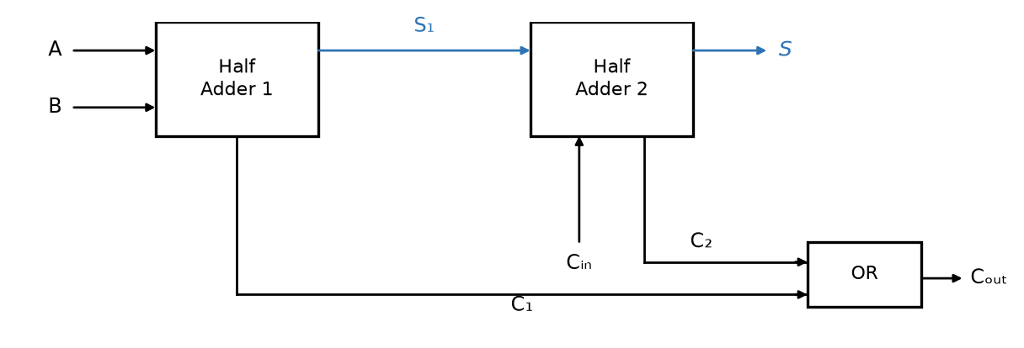
Figure 4.1 — A full adder built from two half adders and an OR gate combining their carry outputs.

4.2 Why Sequential Circuits Need Memory
A combinational adder is stateless by construction: feed it the same two numbers twice, in any order, and it produces the same sum both times. Many useful behaviors cannot be built this way — a counter that increments on each clock pulse must remember what it counted last, and a system that reacts differently to the same input depending on what happened earlier needs somewhere to keep that history. That somewhere is a bistable element: a circuit with two stable states that, left alone, stays in whichever one it is currently in.

4.3 Latches and Flip-Flops
The simplest bistable element, the SR latch, can be built two ways, and the two are not interchangeable in their details. A NOR-gate version uses active-high inputs: setting S = 1 forces the stored output Q to 1, setting R = 1 forces it to 0, and with both inputs at 0 the latch holds whatever value it last stored — but setting both S and R to 1 simultaneously is forbidden, since both cross-coupled gates are then driven to the same output state, and which stable state the latch settles into once both inputs release is not defined by the circuit. A NAND-gate version instead uses active-low inputs, conventionally written S̄ and R̄: a 0 is what sets or resets the latch, and holding both inputs high is what makes it hold its value. There, the forbidden combination is S̄ = R̄ = 0 — the same underlying problem, with the roles of 0 and 1 inverted.
A D flip-flop is the far more common building block in practice: rather than separate set and reset inputs, it has a single data input D and a clock input, and it copies whatever value is on D to its output Q only at the instant the clock transitions (typically low-to-high) — not continuously, the way a latch does. This clocked, edge-triggered behavior is what lets many flip-flops throughout a large digital system change state at exactly the same instant, which is the entire basis of synchronous digital design. A real flip-flop does not sample an arbitrarily changing D at a mathematically precise instant, either: D must actually be stable for a brief setup time before the edge and a brief hold time after it, or the flip-flop's output becomes unpredictable — a timing detail this book will not need until it becomes a first-class design concern in a later book, but worth knowing exists.
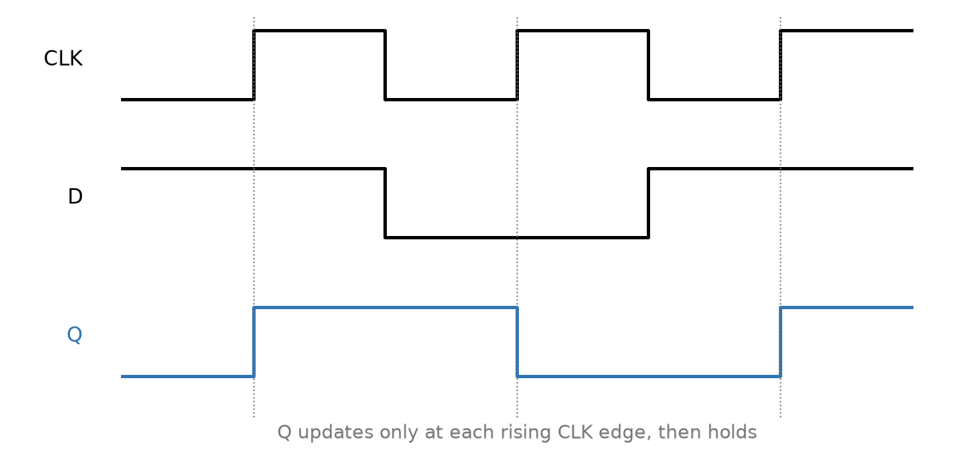
Figure 4.2 — A D flip-flop's timing diagram: Q updates to whatever D holds only at each rising CLK edge, then holds steady.
Key Idea
A flip-flop's output depends on its history, not only on its current inputs — that dependence on the past is the defining property of memory, and the reason sequential circuits can do things no combinational circuit, however large, ever can.

4.4 Registers and Counters
A register is simply a bank of D flip-flops sharing one clock, storing one bit of a multi-bit value in each — an 8-bit register is eight D flip-flops wide, storing one full byte at every clock edge. A counter is a register wired so that its own output, modified slightly (typically incremented by one), becomes the input for the next clock edge, causing it to step through a sequence of values automatically rather than storing whatever value is handed to it externally. A shift register is a third variant: each flip-flop's output feeds the next flip-flop's input directly, so a bit pattern loaded in at one end moves one position through the chain on every clock edge, rather than being held in place (a plain register) or incremented (a counter).
Worked Example 4.2
Problem: A 2-bit binary counter, built from two D flip-flops, starts at 00 and increments by one on every clock edge. List the sequence of states for the first five clock edges, and identify when it rolls over.
Solution: Counting in 2-bit binary from 00: 00 → 01 → 10 → 11 → 00 → 01. The first five edges therefore produce 01, 10, 11, 00, 01 — and the counter rolls over back to 00 on the fourth edge, since two bits can represent only four distinct values (0 through 3) before the sequence must repeat.
This chapter, and the two before it, cover the digital vocabulary this series needs going forward, but they are not a complete treatment of digital design. Propagation delay (how long a gate takes to respond to an input change), clock skew (different flip-flops receiving the same clock edge at very slightly different times), metastability (what happens when a flip-flop's setup or hold time is violated), fan-out (how many gate inputs one output can safely drive), and the practical differences between logic families (TTL, CMOS, LVDS, and others) all matter enormously in a real digital system — and all of them are left for a later, dedicated treatment rather than compressed into a paragraph here.

Practice Problems
- State the forbidden input combination for a NOR-gate (active-high) SR latch, and explain in one sentence why it is forbidden.
- A D flip-flop has D = 1 when a clock edge arrives. What is Q immediately after the edge?
- How many D flip-flops are needed to build a register that can store any 4-bit binary number?
- A half adder has inputs A = 1, B = 0. Find S and C.
- A NOR-gate SR latch has S = 1, R = 0 applied, and then both inputs are returned to 0. What value does Q hold afterward, and why?
- Explain, in a sentence or two, why every flip-flop in a shift register must share the same clock signal.

Chapter 5 — Operational Amplifiers
The operational amplifier, or op-amp, is the single most common building block in analog design, and it earns that status by being simple to reason about despite the elaborate transistor circuitry inside it. This chapter treats the op-amp the way Book 1 treated the resistor, capacitor, and inductor: as an ideal element, defined by a small number of assumptions, whose exact behavior in a circuit can be derived from first principles — leaving the transistor-level detail of how an op-amp achieves these properties to Book 3.

5.1 The Ideal Op-Amp and the Golden Rules
An ideal op-amp is defined by three properties: infinite open-loop voltage gain, infinite input impedance, and zero output impedance. From these follow two rules that make analyzing an op-amp circuit almost entirely a matter of algebra, provided — and this proviso matters — the circuit uses negative feedback to keep the op-amp out of saturation:
Golden Rule 1: V₊ = V₋ (a “virtual short”) Golden Rule 2: I₊ = I₋ = 0
Rule 1 does not claim the two input terminals are actually connected together; no current flows between them, and nothing forces their voltages to match except the surrounding feedback circuit actively adjusting the output until they do. Rule 2 follows directly from infinite input impedance: no real current can flow into either input terminal, so any current arriving at a node connected to an op-amp input must go somewhere else entirely.
Common Misconception
The golden rules are not a property of the op-amp in isolation — they are a property of a correctly designed negative-feedback circuit built around one. Remove the feedback path, or feed the output back to the wrong input, and the op-amp instead saturates hard against one supply rail, and neither golden rule describes its behavior anymore.

5.2 The Inverting Amplifier
The most common op-amp configuration grounds the non-inverting input, applies the input signal through a resistor Rᵢₙ to the inverting input, and feeds the output back to that same inverting input through a resistor R_f. By Golden Rule 1, the inverting input sits at 0 V (a “virtual ground”), since the non-inverting input is grounded. By Golden Rule 2, whatever current flows in through Rᵢₙ has nowhere to go but through R_f to the output:
Vₒᵤₜ = −(R_f / Rᵢₙ) · Vᵢₙ
The negative sign is the defining feature of this configuration: the output is an inverted, scaled copy of the input.
Worked Example 5.1
Problem: An inverting amplifier has R_f = 100 kΩ and Rᵢₙ = 10 kΩ. Find the output for an input of 0.5 V, and verify the result directly from the golden rules.
Solution: Gain = −R_f/Rᵢₙ = −100k/10k = −10. Vₒᵤₜ = −10 × 0.5 = −5 V. Checking directly: the inverting input sits at 0 V (virtual ground), so the current into Rᵢₙ is I = (0.5 − 0)/10k = 50 µA. That current has nowhere to go but through R_f, so Vₒᵤₜ = 0 − (50 µA)(100k) = −5 V — matching the formula exactly.
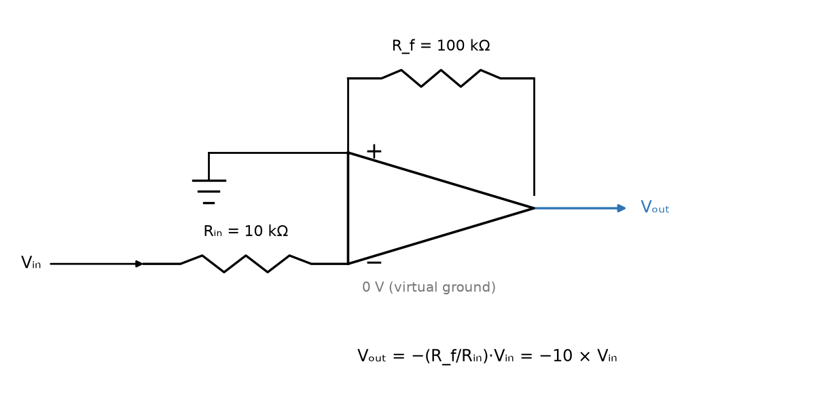
Figure 5.1 — The inverting amplifier: Rᵢₙ from the source to the virtual-ground inverting input, R_f feeding back from the output.

5.3 The Non-Inverting Amplifier
Applying the input directly to the non-inverting terminal, and feeding the output back to the inverting terminal through a voltage divider (R_f from output to the inverting input, Rᵢₙ from the inverting input to ground), gives a gain that is always at least 1 and never inverts the signal:
Vₒᵤₜ = (1 + R_f / Rᵢₙ) · Vᵢₙ
Worked Example 5.2
Problem: A non-inverting amplifier must provide a gain of exactly 6. If Rᵢₙ = 2 kΩ, find R_f.
Solution: 6 = 1 + R_f/Rᵢₙ, so R_f/Rᵢₙ = 5, and R_f = 5 × 2k = 10 kΩ.
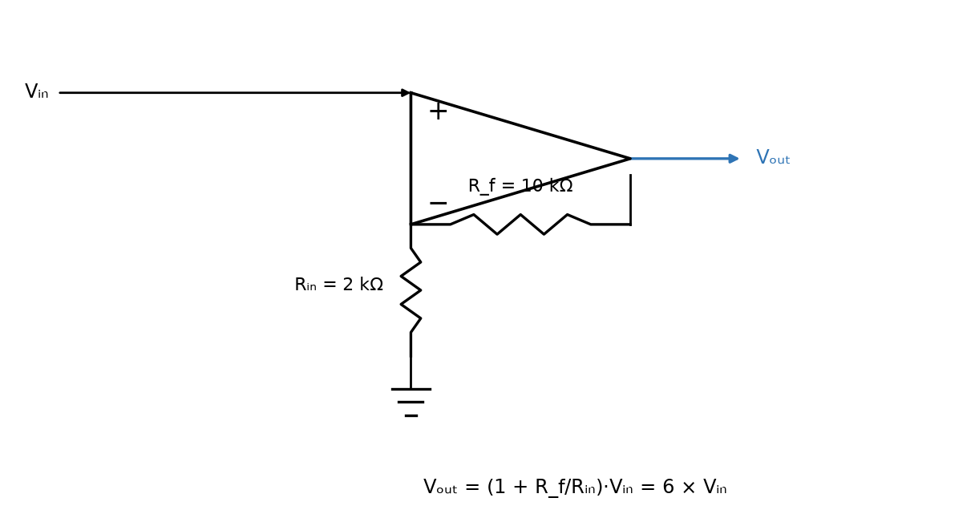
Figure 5.2 — The non-inverting amplifier: the signal drives the non-inverting input directly; R_f and Rᵢₙ form the feedback divider.

5.4 Real Limitations
A real op-amp's open-loop gain is large but finite, and it falls off with frequency — the gain-bandwidth product (GBW) is roughly constant, so a design that needs high gain at high frequency runs out of available gain sooner than one that needs only modest gain. Slew rate limits how fast the output can move at all, regardless of gain, and becomes a hard ceiling on the largest undistorted signal amplitude at high frequency — a close cousin of Chapter 1's headroom limit, but caused by a rate-of-change constraint rather than a voltage constraint. A small input offset voltage, ideally zero, in practice means the output is not exactly zero even when both inputs are nominally at the same voltage.
Worked Example 5.3
Problem: The inverting amplifier from Worked Example 5.1 (R_f = 100 kΩ, Rᵢₙ = 10 kΩ) is powered from ±5 V supply rails. Find the output the ideal gain formula predicts for an input of 1.0 V, and explain what the amplifier actually does instead.
Solution: The ideal formula predicts Vₒᵤₜ = −(R_f/Rᵢₙ)·Vᵢₙ = −10 × 1.0 = −10 V. But no op-amp can output more than its own supply rails allow, and most parts saturate a volt or more short of the rail itself — so instead of reaching −10 V, the output simply clips at whatever its actual negative saturation voltage is (commonly a volt or two above −5 V for an ordinary, non-rail-to-rail part). This is exactly Chapter 1's headroom limit again, reached here because the demanded gain × input product outran what the supply rails can physically provide, rather than because a small AC signal grew too large around a fixed bias point.

Practice Problems
- An inverting amplifier has R_f = 47 kΩ and Rᵢₙ = 4.7 kΩ. Find the gain and the output voltage for an input of 0.2 V.
- A non-inverting amplifier needs a gain of 6 using Rᵢₙ = 2 kΩ (as in Worked Example 5.2) — now find the new gain if R_f is doubled to 20 kΩ while Rᵢₙ stays at 2 kΩ.
- Explain, in a sentence or two, why the “virtual short” of Golden Rule 1 does not mean current can flow between the two input terminals.
- An inverting amplifier has R_f = 220 kΩ and Rᵢₙ = 22 kΩ. Find the gain and the output voltage for an input of 0.15 V.
- A non-inverting amplifier needs a gain of 4. If R_f = 30 kΩ, find Rᵢₙ.
- Explain, in a sentence or two, why an op-amp's output cannot exceed its supply rails, no matter how large the golden-rule-predicted output would be.

Chapter 6 — Passive and Active Filters
Book 1 introduced frequency response by way of a single RC low-pass stage and, separately, RLC resonance. This chapter generalizes both ideas into a single design discipline — filtering — and adds the one genuinely new idea an ideal resistor, capacitor, and inductor alone cannot provide: an active filter, built around an op-amp, that can add gain and isolate its response from whatever load it drives.

6.1 First-Order Filters, Revisited
A single-resistor, single-capacitor low-pass filter passes frequencies below its corner frequency largely unchanged and attenuates frequencies above it, with the corner (or cutoff) frequency set by
fᴄ = 1 / (2πRC)
Swapping the positions of the resistor and capacitor produces the complementary high-pass filter, with the identical formula for its corner frequency. Both are first-order filters, and a first-order filter's response falls off at a fixed rate of −20 dB per decade once past the corner — a fact Book 1's Chapter 18 introduced as an asymptote-reading exercise and this chapter now names properly.
Worked Example 6.1
Problem: Find the corner frequency of an RC low-pass filter with R = 10 kΩ and C = 10 nF.
Solution: fᴄ = 1/(2πRC) = 1/(2π × 10×10³ × 10×10⁻⁹) = 1/(2π × 1×10⁻⁴) ≈ 1591.5 Hz, or about 1.59 kHz.
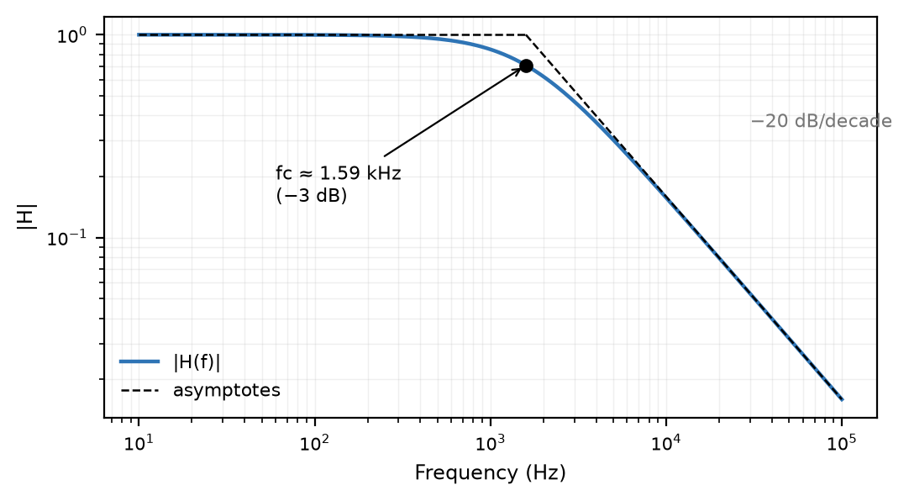
Figure 6.1 — The first-order low-pass response for Worked Example 6.1: flat below fᴄ, falling at −20 dB/decade above it.

6.2 Filter Order and Roll-Off
Cascading filter stages increases the order, and each additional order steepens the roll-off by another −20 dB per decade — a second-order filter falls at −40 dB/decade, a fourth-order filter at −80 dB/decade. Higher order buys a sharper transition between the passband and the stopband, at the cost of a more complex circuit and, for a passive design built from real inductors, often an impractically large or lossy component.
Worked Example 6.2
Problem: The filter from Worked Example 6.1 has fᴄ ≈ 1.59 kHz. Find its attenuation, in dB, at 15.9 kHz — one decade above the corner.
Solution: |H| = 1/√(1 + (f/fᴄ)²) = 1/√(1 + 10²) = 1/√101 ≈ 0.0995. In decibels: 20·log₁₀(0.0995) ≈ −20.0 dB. One decade above the corner, the exact response is already almost indistinguishable from the −20 dB/decade asymptote — confirming why the asymptote is such a reliable shortcut away from the corner itself.

6.3 Band-Pass and Band-Stop Filters
A band-pass filter passes a range of frequencies centered on some frequency of interest and attenuates everything outside that range; the series RLC resonant circuit from Book 1's Chapter 37 already behaves exactly this way, with its bandwidth set by its quality factor Q. A band-stop (or notch) filter does the opposite, rejecting a narrow range of frequencies while passing everything else — the same RLC circuit, connected differently, provides this too.

6.4 Active Filters
Every passive filter discussed so far has one practical drawback: its actual frequency response depends on whatever load impedance is connected to its output, since that load forms part of the circuit the filter's transfer function was derived from. An active filter places an op-amp between the filtering network and the output, using the op-amp's near-zero (though not literally zero) output impedance to strongly isolate the filter's response from the load, and its gain to make up for any signal loss the filtering network introduces — something no arrangement of passive components alone can do, since a real resistor, capacitor, and inductor can only remove energy from a signal, never add it.
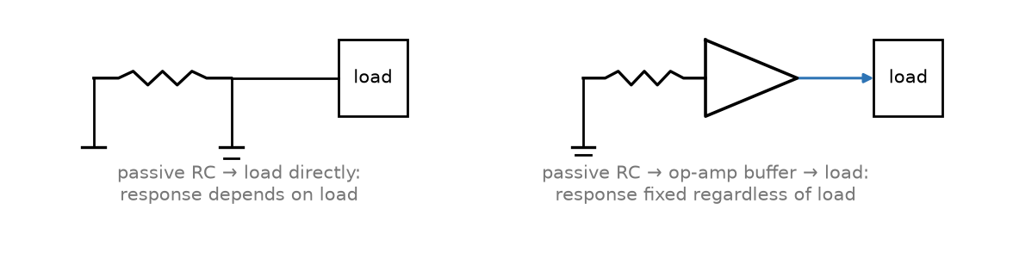
Figure 6.2 — A passive RC stage driving a load directly, versus the same stage buffered by an op-amp before the load.
Key Idea
An active filter's frequency response is largely isolated from whatever load it drives; a passive filter's response is only correct for the specific load it was designed around, and changes — sometimes significantly — if that load changes. “Largely” matters here: a real op-amp's output impedance is small but not zero, and its finite bandwidth limits how well that isolation holds as frequency rises.
Common Misconception
“Active” does not mean “better” in every respect. An active filter needs a power supply and cannot process a signal outside its op-amp's operating voltage range, while a passive filter needs neither and can handle much larger signals — the right choice depends on the application, not a blanket preference for one over the other.
Worked Example 6.3
Problem: Design an RC low-pass filter with a corner frequency of 2 kHz. Choose a practical resistor value first, then compute the capacitor needed, and round to the nearest standard (E12) value.
Solution: Pick a convenient standard resistor value, R = 8.2 kΩ. Solving fᴄ = 1/(2πRC) for C: C = 1/(2π·fᴄ·R) = 1/(2π × 2000 × 8200) ≈ 9.70 nF. The nearest E12 standard capacitor value is 10 nF. Checking the actual corner frequency with the rounded value: fᴄ = 1/(2π × 8200 × 10×10⁻⁹) ≈ 1941 Hz — about 3% below the 2 kHz target, which is well within what a design normally tolerates once component tolerances are considered. Choosing component values is always this last step: solve for the exact value, then round to what a parts bin actually stocks and check the result is still close enough.

Practice Problems
- Find the corner frequency of an RC filter with R = 2.2 kΩ and C = 47 nF.
- A single first-order filter stage rolls off at −20 dB/decade. What is the roll-off of four such stages cascaded together?
- Explain, in a sentence or two, why an active filter's frequency response stays largely unaffected if the load connected to it changes, while a passive filter's does not.
- Find the corner frequency of a high-pass RC filter with R = 3.3 kΩ and C = 15 nF.
- A second-order filter rolls off at −40 dB/decade. Express this same roll-off rate in dB per octave.
- A designer wants to remove 60 Hz power-line hum from a signal of interest at 1 kHz, using only a single first-order high-pass filter. Explain the practical limitation this creates, given the filter's roll-off rate.

Chapter 7 — Resistors
Book 1's resistor was an ideal object obeying V = IR exactly, with no further qualification needed. A real resistor, the physical component a designer actually places on a board, is only an approximation of that ideal — a good one, most of the time, but one with limits worth knowing before they are discovered the hard way.

7.1 Construction and Types
Carbon film and metal film resistors are the ordinary through-hole and surface-mount workhorses, with metal film offering tighter tolerance and lower noise at a modest cost premium. Wirewound resistors, made from a coil of resistive wire, handle far more power than film types of the same size, at the cost of a real disadvantage explored in Section 7.4. Surface-mount chip resistors are a thick- or thin-film resistive layer on a small ceramic substrate, and dominate modern board designs simply on the basis of size.

7.2 Tolerance and the E-Series
No manufacturing process produces a resistor at exactly its labeled value; a tolerance, typically ±1%, ±5%, or ±10%, specifies how far the actual value may stray from nominal. Book 1's Chapter 15 introduced the E-series of standard values (E12, E24, E96) as a set of geometric progressions chosen so that adjacent standard values are spaced by roughly the tolerance band itself — the same logic explains why a 5%-tolerance parts line stocks noticeably fewer distinct values than a 1%-tolerance line.
Worked Example 7.1
Problem: Two 1 kΩ resistors, each with 5% tolerance, are connected in series. Find the range of possible total resistance.
Solution: Each resistor can independently fall anywhere between 950 Ω and 1050 Ω. In the worst case, both resistors are simultaneously at their low extreme or both at their high extreme, giving a total resistance anywhere from 1900 Ω to 2100 Ω.

7.3 Power Rating and Derating
A resistor dissipates power according to the same P = I²R = V²/R relations from Book 1, and every real resistor carries a maximum power rating — commonly 1/8 W, 1/4 W, or 1/2 W for small through-hole and surface-mount parts — set by how much heat its package can shed before overheating. Good design practice leaves real margin below that rating, since the rating itself typically assumes a specific ambient temperature and derates further as ambient temperature rises.
Worked Example 7.2
Problem: An LED circuit runs from a 5 V supply, with the LED's forward voltage at 2 V and a desired current of 20 mA. Find the required series resistor and check whether a 1/8 W (125 mW) resistor is an adequate choice.
Solution: R = (Vₛᵤₚₚₗᵧ − V_f)/I = (5 − 2)/0.02 = 150 Ω. Power dissipated in the resistor: P = I²R = (0.02)² × 150 = 0.06 W = 60 mW. That is within a 1/8 W part's 125 mW rating, but it uses about 48% of that rating, leaving a comparatively modest ~52% margin — a 1/4 W part would leave more comfortable headroom, especially at an elevated ambient temperature.

7.4 Temperature Coefficient and High-Frequency Behavior
A resistor's value drifts slightly with temperature, specified as a temperature coefficient in parts per million per degree Celsius (ppm/°C); metal film types are typically far better in this respect than carbon film. At sufficiently high frequency, no real resistor is purely resistive: a wirewound resistor's coiled construction gives it meaningful parasitic inductance, and any resistor's leads and internal geometry contribute a small parasitic capacitance in parallel with the intended resistance — which is exactly why a wirewound part, excellent for high-power DC and low-frequency AC use, is a poor choice for an RF circuit.
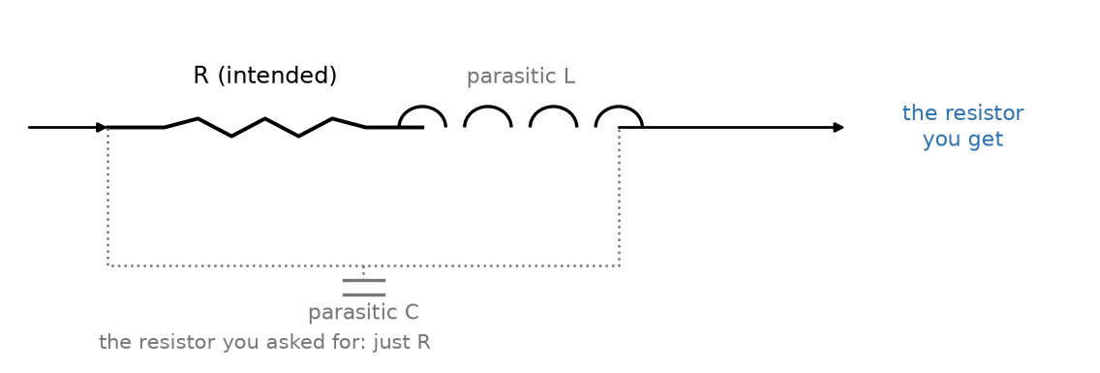
Figure 7.1 — A real resistor: the intended resistance in series with a small parasitic inductance, shunted by a small parasitic capacitance.
Key Idea
Every real component is, at a high enough frequency, secretly a little of the other two as well — a resistor has parasitic inductance and capacitance, precisely as the capacitors and inductors in the next two chapters carry a parasitic resistance of their own.

Practice Problems
- A resistor is rated 1/4 W (250 mW). Find the maximum current it can safely carry if its resistance is 100 Ω.
- Explain, in a sentence or two, why a wirewound resistor is a poor choice for a high-frequency RF circuit even though its DC resistance is perfectly accurate.
- A batch of 1 kΩ resistors is manufactured with 10% tolerance instead of 5%. State the new range of individual resistor values.
- Three 2.2 kΩ resistors, each with 1% tolerance, are connected in series. Find the range of possible total resistance.
- A resistor must dissipate 0.3 W continuously. Standard power ratings available are 1/8 W, 1/4 W, 1/2 W, and 1 W. Which is the smallest rating that gives at least 50% margin above the actual dissipation?
- Explain, in a sentence or two, why a resistor's temperature coefficient matters more in a precision measurement circuit than in a simple LED current-limiting application.

Chapter 8 — Capacitors
The ideal capacitor of Book 1 stores charge in exact proportion to voltage, with no further complication. A real capacitor adds two practical concerns almost every design eventually runs into: what type of capacitor actually suits a given job, and how far its behavior departs from ideal once frequency or voltage push it outside its comfortable range.

8.1 Real Capacitor Types
Ceramic capacitors split into two practically different families sharing one name: Class 1 types (commonly labeled C0G or NP0) hold their rated capacitance almost exactly regardless of applied voltage or temperature, while Class 2 types (X7R, Y5V, and similar) pack far more capacitance into the same size at the cost of a capacitance that measurably decreases as DC voltage across it increases — a real, specified effect called DC bias derating, not a manufacturing defect. Electrolytic capacitors (aluminum and tantalum) reach far higher capacitance values than any ceramic in a comparable size, but are polarized — connecting one backwards is not merely ineffective but can destroy the part, sometimes violently — a failure mode both aluminum and tantalum electrolytics are known for. Film capacitors sit between the two extremes: unpolarized, stable, and typically used where ceramics' voltage sensitivity or electrolytics' polarity requirement is undesirable.
Common Misconception
A Class 2 ceramic capacitor's marked capacitance is a nominal value under specific, standardized test conditions, not a promise the part will supply that capacitance at its actual operating voltage. A 10 µF X7R part biased near its rated voltage can easily deliver less than half its marked capacitance in practice — always check a manufacturer's DC bias curve for a Class 2 part in a voltage-sensitive design.
Worked Example 8.1
Problem: A 10 µF X7R ceramic capacitor's datasheet specifies 50% capacitance loss at its rated 25 V DC bias. Find its actual effective capacitance when operated at that voltage.
Solution: Effective capacitance = 10 µF × (1 − 0.50) = 5 µF — only half of the value printed on the part, exactly the kind of DC bias derating the misconception above warns about. A designer who needed a genuine 10 µF at this bias would have to select a physically larger part, a lower-voltage-rated one operated well under its DC bias curve's knee, or a different dielectric class entirely.

8.2 Voltage Rating and Polarity
Every capacitor carries a maximum voltage rating, and exceeding it risks dielectric breakdown — permanent, often catastrophic failure. For a polarized electrolytic, the rating applies specifically to the correct polarity; reverse voltage, even briefly, is a separate and typically much lower limit, if it is tolerated at all. Good design practice, exactly as with a resistor's power rating in Chapter 7, leaves real margin below the voltage rating rather than designing right up against it.

8.3 ESR, ESL, and Self-Resonant Frequency
A real capacitor is not a pure capacitance: its leads, plates, and internal construction contribute a small equivalent series resistance (ESR) and an equivalent series inductance (ESL) that Book 1's idealized capacitor did not have. At low frequency, the capacitor's own reactance dominates and the part behaves almost exactly as the ideal model predicts. As frequency rises, however, the capacitive reactance 1/(ωC) shrinks while the inductive reactance ωL(ESL) grows, and at one particular frequency — the self-resonant frequency (SRF) — the two cancel exactly:
SRF = 1 / (2π√(L_ESL · C))
Above the SRF, the part's impedance is dominated by its parasitic inductance and it stops behaving like a capacitor at all — a critical consideration when choosing a bypass or decoupling capacitor for a high-frequency circuit, since a capacitor operated well above its own SRF provides essentially no filtering benefit.
Worked Example 8.2
Problem: A capacitor has C = 100 nF and an equivalent series inductance of 5 nH. Find its self-resonant frequency.
Solution: SRF = 1/(2π√(LC)) = 1/(2π√(5×10⁻⁹ × 1×10⁻⁷)) = 1/(2π√(5×10⁻¹⁶)) = 1/(2π × 2.236×10⁻⁸) ≈ 7.12 MHz. Above roughly 7 MHz, this part's parasitic inductance, not its 100 nF rating, dominates its behavior.
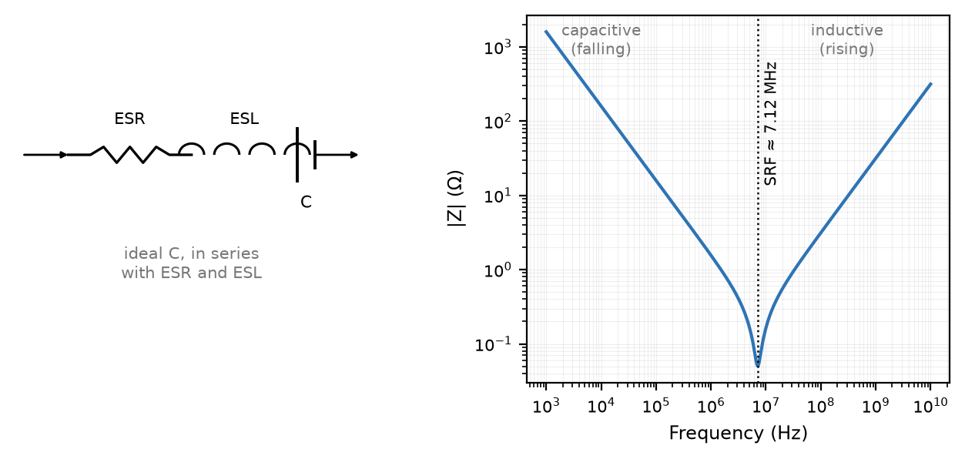
Figure 8.1 — A real capacitor's ESR/ESL model, and the characteristic V-shaped impedance curve with its self-resonant frequency.

Practice Problems
- Find the self-resonant frequency of a 220 nF capacitor with 2 nH of equivalent series inductance.
- An electrolytic capacitor is rated for 16 V. A circuit rail sits at a nominal 12 V DC with a ripple that occasionally peaks to 16.5 V. Is this capacitor an acceptable choice? Explain.
- Explain, in a sentence or two, why a Class 2 (X7R) ceramic capacitor's actual capacitance depends on the DC voltage applied to it.
- Find the self-resonant frequency of a capacitor with C = 10 nF and an equivalent series inductance of 8 nH.
- A tantalum capacitor is rated for 10 V. Manufacturers commonly recommend derating tantalum capacitors to 50% of their rated voltage for reliability. Is a 6 V DC rail acceptable under this guideline, even though it is below the part's absolute 10 V rating?
- Explain, in a sentence or two, why a designer might choose a film capacitor over a higher-capacitance-density ceramic for a precision timing circuit.

Chapter 9 — Inductors
Book 1's Chapter 10 introduced the solenoid and the effect a ferromagnetic core has on its field, and Chapter 37 introduced the ideal inductor's role in a resonant circuit. This closing chapter treats the inductor the way the previous two chapters treated the resistor and capacitor: as a real component with real, specified limitations.

9.1 Real Inductor Types
An air-core inductor — a coil with no core material at all — is simple, perfectly linear regardless of current, and immune to the core-saturation effects of Section 9.2, but achieves relatively little inductance for its size. A ferrite- or iron-core inductor, exactly as Book 1's Chapter 10 described, multiplies the inductance dramatically for the same coil by concentrating the magnetic field in a high-permeability material, at the cost of the saturation behavior that material introduces. A toroidal (ring-shaped) core goes further still, closing the magnetic path on itself so that essentially all of the field stays confined within the core — both increasing inductance per turn beyond an equivalent open rod core and sharply reducing the stray field that would otherwise radiate outward as electromagnetic interference.

9.2 Core Saturation and Losses
A ferromagnetic core's enormous permeability comes from its internal magnetic domains aligning with the applied field; once current is high enough that essentially all of those domains have aligned, the core is saturated, and further increases in current no longer produce a proportional increase in flux. An inductor driven into saturation loses most of its inductance abruptly, right when a circuit's design may most depend on it — a large surge current, for instance, is exactly the situation this failure mode tends to appear in. Beyond saturation, a real core also dissipates a small amount of energy on every cycle as heat, through hysteresis losses (the core's magnetic domains lagging the applied field) and eddy-current losses (small circulating currents induced within the core material itself).
Common Misconception
Core saturation is not a sudden, single threshold so much as it looks like one in practice: inductance falls off increasingly sharply as current approaches the saturation region, so a design with even a small margin below the manufacturer's rated saturation current can behave very differently from one pushed right up against it.
Worked Example 9.1
Problem: An inductor is rated for a saturation current of 3.0 A. In a circuit, it carries a DC bias current of 2.0 A plus an AC ripple with a peak amplitude of 0.8 A. Find the peak instantaneous current and determine whether the inductor risks saturating.
Solution: Peak current = DC bias + AC peak = 2.0 + 0.8 = 2.8 A. This is below the 3.0 A rated saturation current, so the inductor does not saturate — but the margin is only 0.2 A, about 7% of the rating, which is tight enough that a designer would normally choose a higher-Isat part or reduce the ripple rather than rely on so little headroom.

9.3 DCR, Quality Factor, and Self-Resonance
A real inductor's winding has some DC resistance (DCR) — the wire itself is not a perfect conductor — which Book 1's ideal inductor did not include. The quality factor, already introduced in Book 1's Chapter 37 for a resonant circuit as a whole, applies equally to a single real inductor considered on its own:
Q = ωL / R
where R here is the inductor's own DCR (or, more precisely, its total effective series resistance at the frequency of interest, which rises somewhat with frequency due to skin effect). A high-Q inductor stores and returns energy efficiently; a low-Q inductor dissipates a significant fraction of it as heat on every cycle. Exactly as with the capacitor in Chapter 8, a real inductor also has a self-resonant frequency, set this time by its own winding capacitance resonating with its intended inductance, above which it stops behaving like an inductor at all.
Worked Example 9.2
Problem: An inductor has L = 10 µH and a DC resistance of 0.5 Ω, operating at 1 MHz. Find its quality factor.
Solution: ω = 2πf = 2π × 1×10⁶ ≈ 6.283×10⁶ rad/s. ωL = 6.283×10⁶ × 10×10⁻⁶ ≈ 62.83. Q = ωL/R = 62.83/0.5 ≈ 125.7 — a high-Q inductor, storing energy far more efficiently than it dissipates it at this frequency.
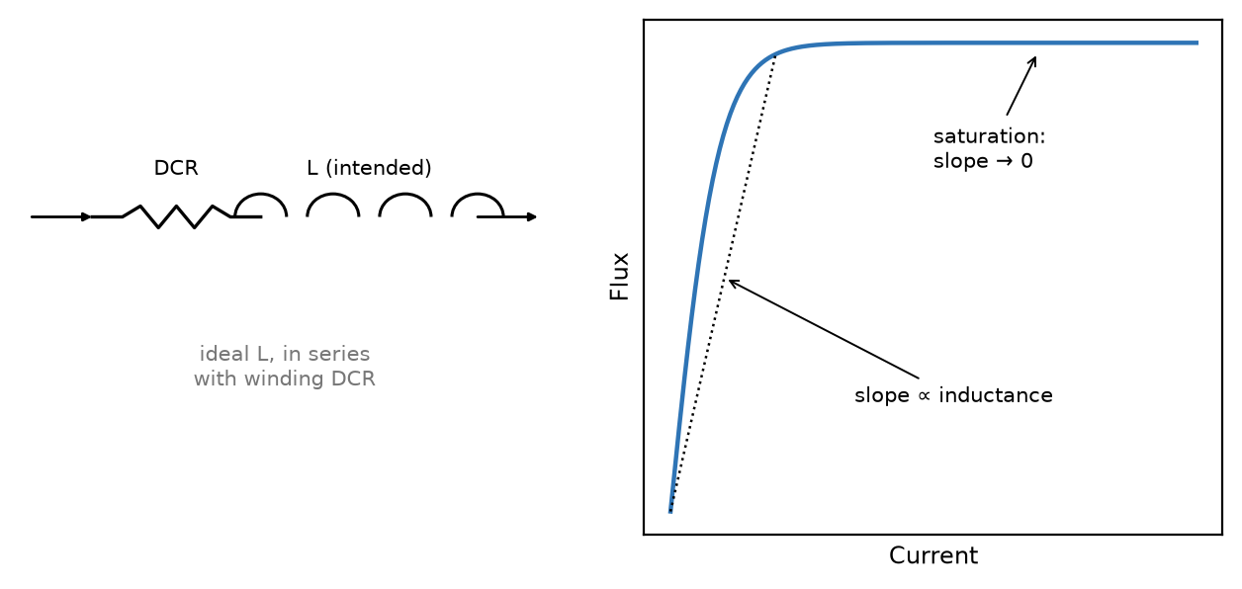
Figure 9.1 — A real inductor's DCR model, and its flux-versus-current curve flattening as the core saturates.

Practice Problems
- An inductor has L = 100 µH and a DC resistance of 2 Ω, operating at 500 kHz. Find its quality factor.
- Why does an inductor's effective inductance drop sharply once its core saturates, rather than declining gradually from the very first microamp of current?
- A toroidal inductor is often chosen over an air-core solenoid of the same inductance in a compact design with nearby sensitive circuitry. Explain why, referring back to Book 1's discussion of a solenoid's field.
- An inductor has L = 47 µH and a DC resistance of 1.2 Ω, operating at 2 MHz. Find its quality factor.
- An inductor is rated for a saturation current of 1.5 A. A circuit's DC bias current is 1.0 A with an AC ripple peak of 0.6 A. Find the peak instantaneous current and state whether it exceeds the rated saturation current.
- Explain, in a sentence or two, why an inductor's quality factor typically peaks and then decreases at very high frequencies, even though Q = ωL/R alone suggests Q should keep rising with ω.

Appendix A — Formula Reference
Concept | Formula
Noise margins | NMʜ = Vₒₕ(min) − Vᵢₕ(min) NMʟ = Vᵢʟ(max) − Vₒʟ(max)
Inverting amplifier | Vₒᵤₜ = −(R_f / Rᵢₙ) · Vᵢₙ
Non-inverting amplifier | Vₒᵤₜ = (1 + R_f / Rᵢₙ) · Vᵢₙ
RC filter corner frequency | fᴄ = 1 / (2πRC)
Capacitor self-resonant frequency | SRF = 1 / (2π√(L_ESL · C))
Inductor quality factor | Q = ωL / R
Inductor self-resonant frequency | SRF = 1 / (2π√(L · C_wind))

Appendix B — Practice Problem Solutions

Chapter 1 Solutions
1. Headroom to the lower rail: 6 − 1 = 5 V. Headroom to the upper rail: 11 − 6 = 5 V. Both are equal, so the largest symmetric amplitude is 5 V, and either rail clips first if pushed further — a well-centered bias point.
2. Output headroom: min(2 − 0, 5 − 2) = min(2, 3) = 2 V. Input amplitude for that output swing: 2 V / 20 = 0.1 V = 100 mV.
3. A small-signal model linearizes a curved response around one specific point; move far enough from that point and the curve departs from its tangent line, so the linear approximation — and any gain figure derived from it — no longer applies.
4. Output headroom: min(4.5 − 0, 9 − 4.5) = 4.5 V (the bias point is centered, so both headrooms are equal). Maximum input amplitude: 4.5 V / 8 = 0.5625 V = 562.5 mV.
5. Headroom to the lower rail: 1 − 0 = 1 V. Headroom to the upper rail: 5 − 1 = 4 V. The lower rail limits, with only 1 V of headroom.
6. Doubling the gain does not change the output headroom, which is fixed entirely by the bias point and the rails. Since output amplitude = gain × input amplitude, reaching the same output headroom now takes only half the input amplitude — the maximum undistorted input amplitude is halved.

Chapter 2 Solutions
1. NMʜ = 3.5 − 2.0 = 1.5 V. NMʟ = 0.5 − 0.2 = 0.3 V.
2. 1011₂ = 8 + 0 + 2 + 1 = 11₁₀.
3. Each digital gate reads a noisy input and regenerates a fresh, full-strength output level, discarding whatever noise arrived with it. Each analog stage instead amplifies signal and noise together, so degradation accumulates rather than resets at every stage.
4. NMʜ = 4.4 − 3.15 = 1.25 V. NMʟ = 1.35 − 0.1 = 1.25 V.
5. 11010₂ = 16 + 8 + 0 + 2 + 0 = 26₁₀.
6. A published noise margin describes only how much steady, DC-like noise a signal can tolerate before a bit is misread — it says nothing about the actual noise environment a design sits in. An industrial setting can couple in transient spikes, ground bounce, or electromagnetic interference whose character (fast edges, repeated bursts) defeats a margin that would be perfectly adequate against ordinary thermal noise, so layout, shielding, and filtering still matter even with generous margins on paper.

Chapter 3 Solutions
1. F = A(A + B) = AA + AB = A + AB = A(1 + B) = A — the absorption law.
2. F = A′B + AB′: 00→0, 01→1, 10→1, 11→0. This is the XOR operation.
3. (A + B)′ = A′B′.
4. H = A + AB′C = A(1 + B′C) = A·1 = A — direct absorption: A OR (A AND anything) is always just A.
5. F = A′(B′C′ + B′C + BC′ + BC) = A′(B′(C′+C) + B(C′+C)) = A′(B′ + B) = A′·1 = A′ — the four terms cover every combination of B and C, so they sum to 1, leaving F = A′.
6. ((A + B)·C)′ = (A + B)′ + C′ (De Morgan's law on the outer AND) = A′B′ + C′ (De Morgan's law again, on (A + B)′).

Chapter 4 Solutions
1. S = 1 and R = 1 simultaneously is forbidden: both cross-coupled gates are driven to the same output state, so which stable state the latch settles into once both inputs release is not determined by the circuit.
2. Q = 1 — a D flip-flop copies D to Q at the clock edge.
3. Four — one flip-flop per bit.
4. S = A ⊕ B = 1 ⊕ 0 = 1. C = AB = 1·0 = 0.
5. Q = 1 afterward: S = 1 forces Q to 1, and once both inputs return to 0 the latch simply holds whatever it last stored.
6. Every flip-flop must change state at exactly the same instant for the shifted data to move correctly from one stage to the next; if even one flip-flop's clock arrived at a different time, that stage could read from (or write to) its neighbor before or after the intended instant, corrupting the shifted sequence.

Chapter 5 Solutions
1. Gain = −47 kΩ/4.7 kΩ = −10. Vₒᵤₜ = −10 × 0.2 = −2 V.
2. With R_f doubled to 20 kΩ and Rᵢₙ unchanged at 2 kΩ: gain = 1 + 20 kΩ/2 kΩ = 1 + 10 = 11 (up from 6).
3. No real current can flow into either input of an ideal op-amp (Golden Rule 2, infinite input impedance). Golden Rule 1's equality of voltage is enforced indirectly, by the feedback network continuously adjusting the output — not by any direct electrical connection between the two inputs.
4. Gain = −220 kΩ/22 kΩ = −10. Vₒᵤₜ = −10 × 0.15 = −1.5 V.
5. 4 = 1 + R_f/Rᵢₙ, so R_f/Rᵢₙ = 3, and Rᵢₙ = R_f/3 = 30 kΩ/3 = 10 kΩ.
6. The golden rules assume ideal, unlimited linear operation, but a real op-amp's output is physically bounded by its supply rails. Once the golden-rule formula predicts an output beyond those rails, the amplifier instead saturates and clips at the rail — exactly the same headroom limit Chapter 1 introduced for any analog stage.

Chapter 6 Solutions
1. fᴄ = 1/(2π × 2200 × 4.7×10⁻⁸) ≈ 1539 Hz, or about 1.54 kHz.
2. Four stages at −20 dB/decade each cascade to −80 dB/decade.
3. An active filter's op-amp output has near-zero (not literally zero) output impedance, so the load can barely interact with the filtering network's own transfer function. A passive filter's output is the filtering network itself, so any load forms a voltage divider with it and changes the actual response.
4. fᴄ = 1/(2π × 3300 × 1.5×10⁻⁸) ≈ 3215 Hz, or about 3.22 kHz.
5. −40 dB/decade ÷ 3.32 (the number of octaves in a decade) ≈ −12 dB/octave — the standard "6 dB/octave per order" rule, doubled for a second-order filter.
6. A first-order filter rolls off at only −20 dB/decade, and 60 Hz sits barely over a decade below 1 kHz. A single pole cannot attenuate 60 Hz meaningfully without also attenuating some of the nearby 1 kHz signal of interest — a higher-order filter, or a notch filter targeted specifically at 60 Hz, is needed for adequate rejection without touching the desired signal.

Chapter 7 Solutions
1. I = √(P/R) = √(0.25/100) = √0.0025 = 0.05 A = 50 mA.
2. A wirewound resistor is physically a coil of wire, which behaves as a real inductor at high frequency; its parasitic inductance dominates well before a film resistor's much smaller parasitic effects would.
3. At 10% tolerance, a 1 kΩ resistor's actual value can fall anywhere from 900 Ω to 1100 Ω.
4. Each resistor can independently fall between 2178 Ω and 2222 Ω (±1% of 2200 Ω). Worst-case series total: 3 × 2178 = 6534 Ω to 3 × 2222 = 6666 Ω.
5. With 50% margin, the resistor needs at least 0.3 × 1.5 = 0.45 W of rated capacity. The 1/4 W (0.25 W) rating is already below the actual dissipation, so it fails outright; the 1/2 W (0.5 W) rating is the smallest of the four that clears 0.45 W.
6. A precision measurement circuit needs the resistance to stay accurate throughout operation, since any temperature-driven drift directly corrupts the measurement. An LED current-limiter only needs current "close enough" — the LED's brightness tolerates modest current variation without any functional consequence, so a resistor's drift there is far less consequential.

Chapter 8 Solutions
1. SRF = 1/(2π√(2×10⁻⁹ × 2.2×10⁻⁷)) ≈ 7.59 MHz.
2. No — the 16.5 V peak exceeds the part's 16 V rating outright, regardless of the nominal 12 V level. A higher-rated part (commonly 25 V) should be used instead.
3. A Class 2 dielectric's high permittivity comes from a ferroelectric-like material whose permittivity itself decreases as the applied DC field increases — a real, documented material property, which is why manufacturers publish DC-bias derating curves for these parts.
4. SRF = 1/(2π√(8×10⁻⁹ × 1×10⁻⁸)) ≈ 17.79 MHz.
5. No — 50% of the 10 V rating is 5 V, and the 6 V rail exceeds that recommended derated limit even though it is comfortably below the part's absolute 10 V rating. A higher-voltage-rated part would give proper reliability margin under the 50% guideline.
6. A film capacitor's capacitance does not shift with applied DC voltage the way a Class 2 ceramic's does, and it holds a more stable, predictable value over voltage and temperature generally — which matters directly in a timing circuit (such as an RC oscillator), where the actual capacitance must stay close to its nominal value for the timing to stay accurate.

Chapter 9 Solutions
1. ωL = 2π × 5×10⁵ × 1×10⁻⁴ ≈ 314.2. Q = 314.2/2 ≈ 157.1.
2. Saturation reflects the core's magnetic domains running out of room to align further; once nearly all domains are aligned, additional current produces little additional flux, so inductance collapses rather than declining gradually from the start.
3. A toroid's closed magnetic loop confines nearly all of the field within the core, concentrating flux far more effectively per turn than an open air-core solenoid — boosting achievable inductance in a smaller package while minimizing stray field that could couple into nearby circuitry as EMI.
4. ωL = 2π × 2×10⁶ × 4.7×10⁻⁵ ≈ 590.6. Q = 590.6/1.2 ≈ 492.2.
5. Peak current = 1.0 + 0.6 = 1.6 A, which exceeds the 1.5 A rated saturation current — this design risks saturating and needs either a higher-Isat inductor or a reduction in ripple or bias current.
6. At high frequency, an inductor's effective series resistance R itself rises — from skin effect in the winding and from core losses (hysteresis and eddy currents) — growing faster than ω does. Eventually that rising R outpaces ωL's growth, so Q peaks and then falls, rather than climbing indefinitely as the idealized Q = ωL/R formula alone would suggest.

Appendix C — Glossary
Absorption law — A + AB = A, or its dual A(A + B) = A; a term adding no new information can be removed from a Boolean expression.
Active filter — A filter built around an op-amp, whose low output impedance largely isolates its frequency response from the load it drives, and whose gain can also make up for any signal loss the filtering network introduces.
Bias point (Q-point) — The fixed DC operating condition a circuit is set to before a smaller signal is applied on top of it.
Boolean algebra — The algebra of AND, OR, and NOT, used to describe and simplify digital logic.
Class 2 dielectric — A ceramic capacitor dielectric family (X7R, Y5V, and similar) that packs more capacitance into a given size than Class 1 types, at the cost of capacitance that decreases as DC bias voltage rises.
Clipping — Distortion caused by a signal's peaks being cut flat at a circuit's output rail.
Combinational circuit — A circuit whose output depends only on its present inputs, with no memory of the past.
De Morgan's laws — (A + B)′ = A′B′, and (AB)′ = A′ + B′.
ESR / ESL — Equivalent series resistance / equivalent series inductance — the real, non-ideal resistive and (for a capacitor) inductive components no ideal model includes; this book calls a real inductor's own series resistance its DCR instead, since an inductor's self-resonance comes from parasitic winding capacitance, not a parasitic inductance of its own.
Flip-flop — A clocked, edge-triggered bistable circuit that stores one bit, updating only at a clock transition.
Gain — The ratio of a circuit's output signal to its input signal.
Golden rules (op-amp) — V₊ = V₋ and I₊ = I₋ = 0; the two assumptions that make an ideal op-amp circuit with negative feedback solvable by algebra alone.
Headroom — The distance from a circuit's bias point to the nearer of its two output rails, setting the largest signal it can pass undistorted.
Karnaugh map — A grid arrangement of a truth table's outputs in which every adjacent cell differs in exactly one input bit, letting groups of adjacent 1s be read off directly as a simplified Boolean expression.
Latch — An unclocked bistable circuit whose output can change at any time its inputs allow, unlike a flip-flop.
Noise margin — The gap between a gate's guaranteed output level and the next gate's guaranteed input threshold, for a given logic level.
Quality factor (Q) — A measure of how efficiently a resonant circuit or reactive component stores energy versus dissipating it as heat; for an inductor, Q = ωL/R.
Regeneration — A digital gate reading a noisy input and producing a fresh, full-strength output level, which is why noise does not accumulate through a long chain of gates.
Self-resonant frequency (SRF) — The frequency at which a real capacitor's or inductor's parasitic reactance cancels its intended reactance.
Sequential circuit — A circuit whose output depends on both its present inputs and its stored history.
Small-signal analysis — Treating a circuit's response to a sufficiently small signal as linear, even when the underlying device is not linear over its full range.
Tolerance — The manufacturer-specified range within which a real component's actual value may fall relative to its nominal, labeled value.

Appendix D — Chapter Summaries

Chapter 1
A circuit is biased to a fixed operating point before a smaller signal rides on top of it; the distance from that point to the nearer output rail is its headroom, and headroom sets the largest undistorted signal the stage can pass; gain and headroom trade against each other for a fixed pair of supply rails, and exceeding that limit produces distortion, most visibly as clipping.

Chapter 2
Digital signals use two voltage ranges rather than a continuous one, separated by a forbidden gap. Noise margin measures how much of that gap protects against misread bits, and it is regeneration — each gate reading and re-outputting a fresh level — that keeps digital signals clean over long chains; binary place-value notation is how those two levels represent multi-bit numbers.

Chapter 3
Boolean algebra's laws, especially De Morgan's, let a logic expression be simplified without a truth table; Karnaugh maps do the same visually for more variables than algebra alone easily handles.

Chapter 4
Combinational circuits compute from present inputs alone; sequential circuits add memory via bistable elements — the SR latch and, far more commonly in practice, the clocked D flip-flop — that depend on their own history; chaining flip-flops together builds registers, counters, and shift registers.

Chapter 5
The ideal op-amp's golden rules — equal input voltages, zero input current — hold only under negative feedback, and from them the inverting and non-inverting amplifier gain formulas follow directly by algebra; a real op-amp's output still saturates at its supply rails once the ideal formula predicts more than they can provide.

Chapter 6
A filter's order sets its roll-off rate at −20 dB/decade per order; a band-pass or band-stop (notch) filter targets a range of frequencies rather than a single cutoff; an active filter adds an op-amp to isolate its response from the load and to add gain, something no passive network alone can do.

Chapter 7
A real resistor departs from Book 1's ideal model through tolerance, power rating, temperature drift, and — at high frequency — parasitic inductance or capacitance, depending on its construction.

Chapter 8
Every capacitor carries a maximum voltage rating, and for a polarized electrolytic that rating applies to the correct polarity only; a real capacitor's equivalent series resistance and inductance also give it a self-resonant frequency, above which it stops behaving like a capacitor, and Class 2 ceramic types lose capacitance as DC bias voltage rises.

Chapter 9
Real inductor construction (air-core, ferrite- or iron-core, toroidal) trades off linearity, size, and stray field; a real inductor's core can also saturate, collapsing its inductance; its quality factor Q = ωL/R measures how efficiently it stores energy versus dissipating it, and it too has a self-resonant frequency above which it stops behaving like an inductor.

Appendix E — Further Reading
This book derives and verifies every result it uses from first principles, so none of the following is required to read it. They are listed for readers who want to go beyond a single chapter in a given area.
Paul Horowitz and Winfield Hill, The Art of Electronics — the standard broad reference for practical, component-level electronics; touches nearly every topic in this book at greater depth, from op-amp circuits to real-component behavior.
Sergio Franco, Design with Operational Amplifiers and Analog Integrated Circuits — a rigorous next step for Chapter 5, covering real op-amp non-idealities and analog IC design beyond the ideal golden-rule treatment given here.
M. Morris Mano, Digital Design — the standard textbook for Chapters 2–4, extending Boolean algebra and sequential circuits into full digital system design.
Don Lancaster, Active Filter Cookbook — a practical, design-oriented companion to Chapter 6, with many worked active-filter topologies beyond the single buffered stage introduced here.
Paul Scherz and Simon Monk, Practical Electronics for Inventors — a broad, hands-on reference for Chapters 7–9's real components — tolerances, ratings, and how to actually choose a part for a design.

